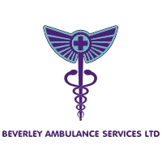

Vision
To Deliver high standards of care within the family run ambulance service we provide, and to be caring and compassionate to all our service users.
Values
Friendly
Accessible to all
Medically Safe
Inclusive Care
Leading by example
You come first

